Assignment: A Hero

A hero is someone we look up to or admire because of his or her outstanding qualities or achievements. A hero can be someone close to us, such as a relative, friend or neighbor. They may also include stars of today such as athletes, actors, musicians, or artists.
Here are some characteristics of a hero:
Bravery - Courage - Determination - Helpful - Honesty - Inspirational….

What do you think it takes to be a hero? In this assignment, you will select someone you consider to be a hero.

Answer these questions to get started:

- What is your definition of a hero?

- What are the extraordinary qualities of a hero?

- Who is the person you selected and why did you select him/her?

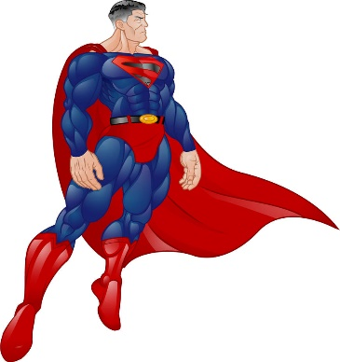
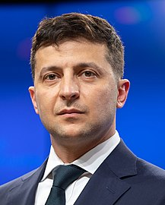

Dette billede efter Ukendt forfatter er licenseret under CC BY-NC-ND

Dette billede efter Ukendt forfatter er licenseret under CC BY

