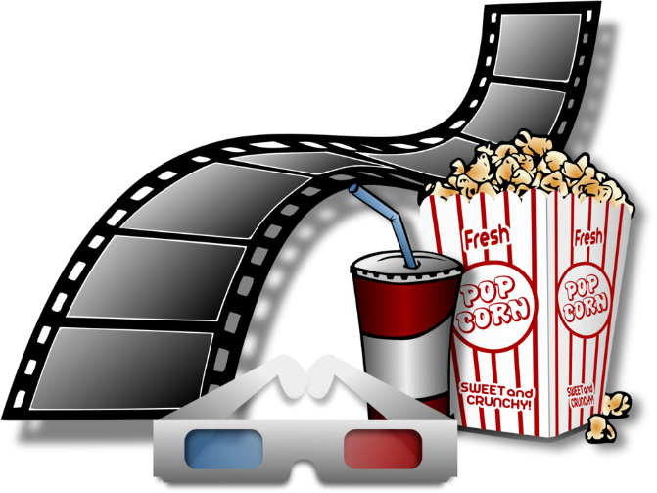
A good movie

Title: What is the name of the movie?
Release year: When was the movie released?
Director: Who directed the movie?
Genre features: What genre features does the movie have?
Playing time: How long is the movie?
Summary: Short retelling of the movie
Time: When does the movie take place?
People: Who do we meet - which people are important to the story?
The main character: A description of the main character?
Place: Where does the movie take place?
Actor: Tell us about one of the actors?
Evaluate: What do you think of the movie?

